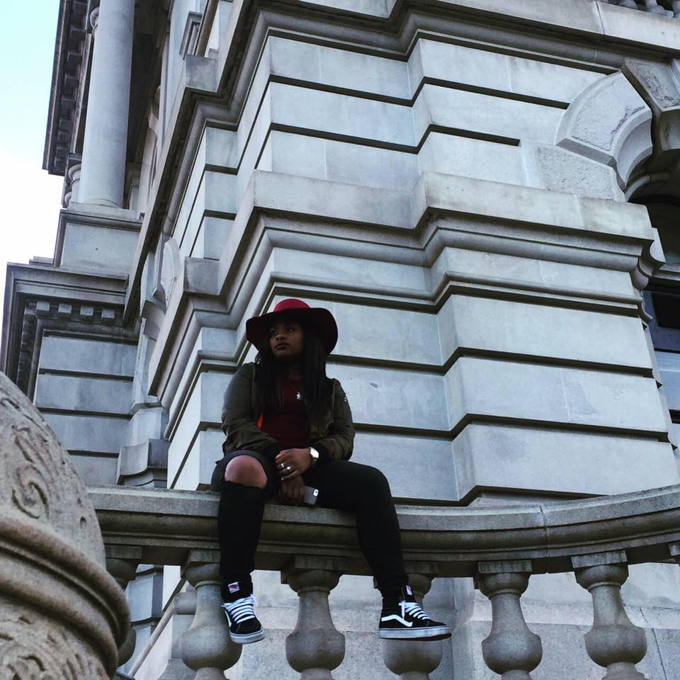
INDEPENDENT RECORDING ARTIST “Lavish Loe” Press Release
New York native Lavish Loe has the rap game in a choke hold! Loe is known for her lengthy, bar filled freestyles, gaining her thousands of views on her Instagram @LOEYola. Keeping that momentum Loe released her first song, a radio hit titled ‘Bust It Up’ in September 2017, which gained her 500 plays on SoundCloud within the first month. Loe then dropped ‘The Intro’ video on YouTube, introducing herself to the world. The Intro video gained her a thousand more views with all her platforms combined. To follow up with the ‘BUST IT UP’ single Loe put out a now, well-known hood melody titled ‘HEARTLESS’ and then dropped another single titled ‘Bricks & Bankrolls.
Single after single, freestyle after freestyle LOE keeps it coming with timeless music, keeping the streets on fire. Loe took a social media hiatus in January 2018 due to overwhelming support after opening for A-boogie at a concert in Geneva, NY. By February of 2018 she got right back out there and continued doing shows throughout the Tristate area. She has worked closely with Boom 103.9 FM Dj DiorCartel, Sirius XM Dj Da Inphamus Amadeuz and Damatrix Studio Radio OG Harlem’s First Lady to name a few. Loe is out here building her fan base the old fashion way, putting in that foot work and performing at local clubs in different cities. After visiting Urban Culture Radio in Philadelphia, PA LOE has been declared the Female Mase of the modern-day rap game. Her highly anticipated debut Mixtape ‘For the Culture’ is set to release on May 15th, 2018. The Tape will be available on her website: https://loegatesmusic.wixsite.com/loemusic and all other major music platforms.

Photos for Media use:
